# Appendices for manuscript:

## How an unprecedented wildfire shaped tree hollow occurrence and abundance - implications for arboreal fauna

Benjamin Wagner1*, Patrick J. Baker1 & Craig R. Nitschke1

1School of Agriculture, Food and Ecosystem Sciences, The University of Melbourne, 500 Yarra Boulevard, Richmond, 3121 VIC, Australia

**\***Correspondence: Benjamin Wagner ([benjamin.wagner@unimelb.edu.au](mailto:benjamin.wagner@unimelb.edu.au))

Appendix S1 – Supplementary figures: Pages 2-7

Appendix S2 - Supplementary tables: Pages 8-19

Appendix S3 - Multivariate hollow occurrence grouped model results: Page 20

# Appendix S1: Supplementary Figures

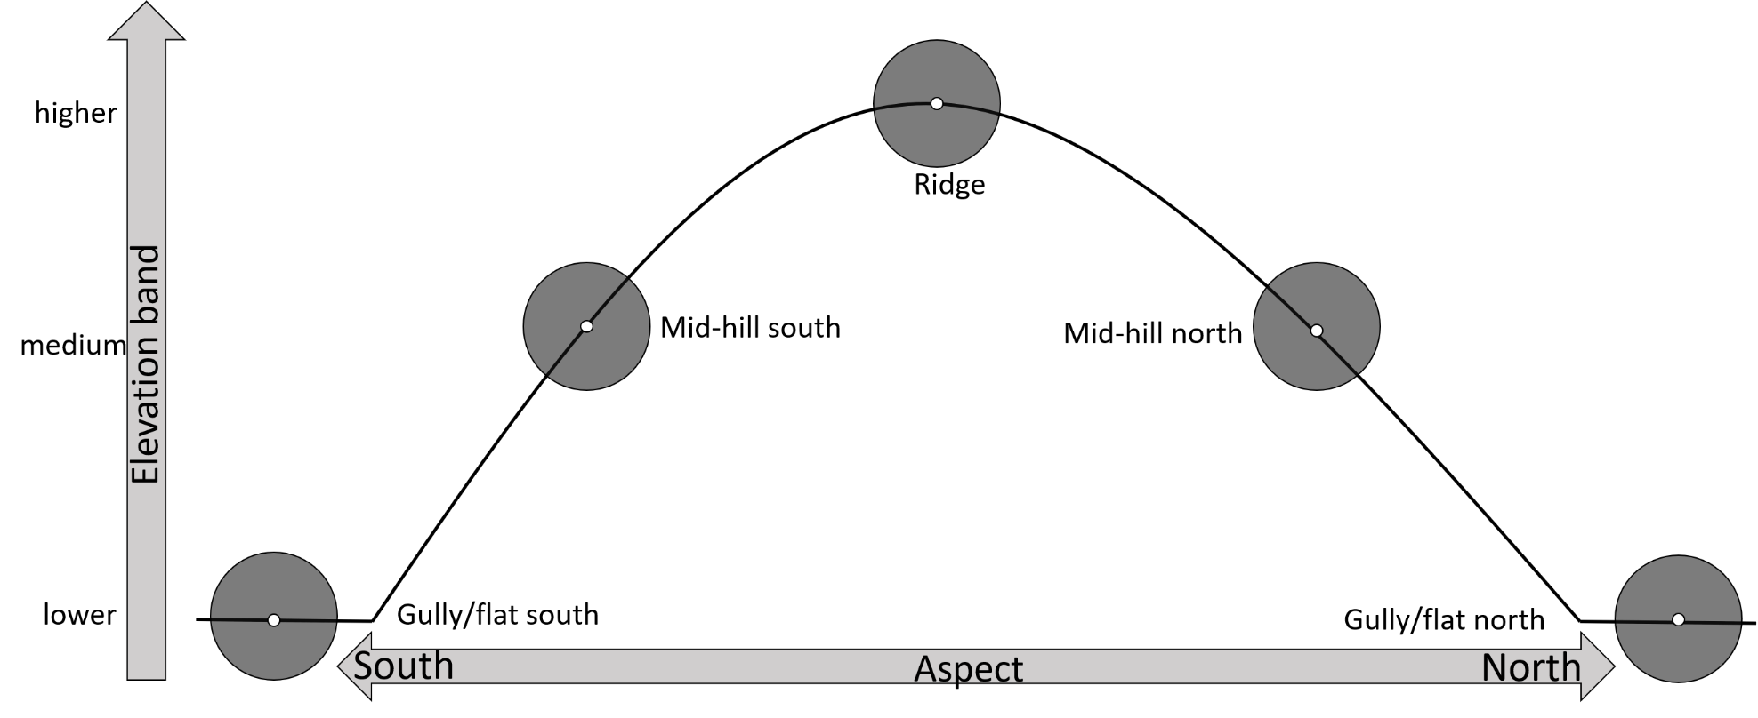

**Figure S1. *Pre-fire* plot selection: Six of these virtual landscape-scale transect were established within three elevation bands (two transects per band) between sea level and ~1200 m.a.s.l. Transects were designed to ensure capturing the topographic variability of the landscape as expressed by elevation, slope and aspect and through that a variety of dominant *Eucalyptus* species forming the canopy.**

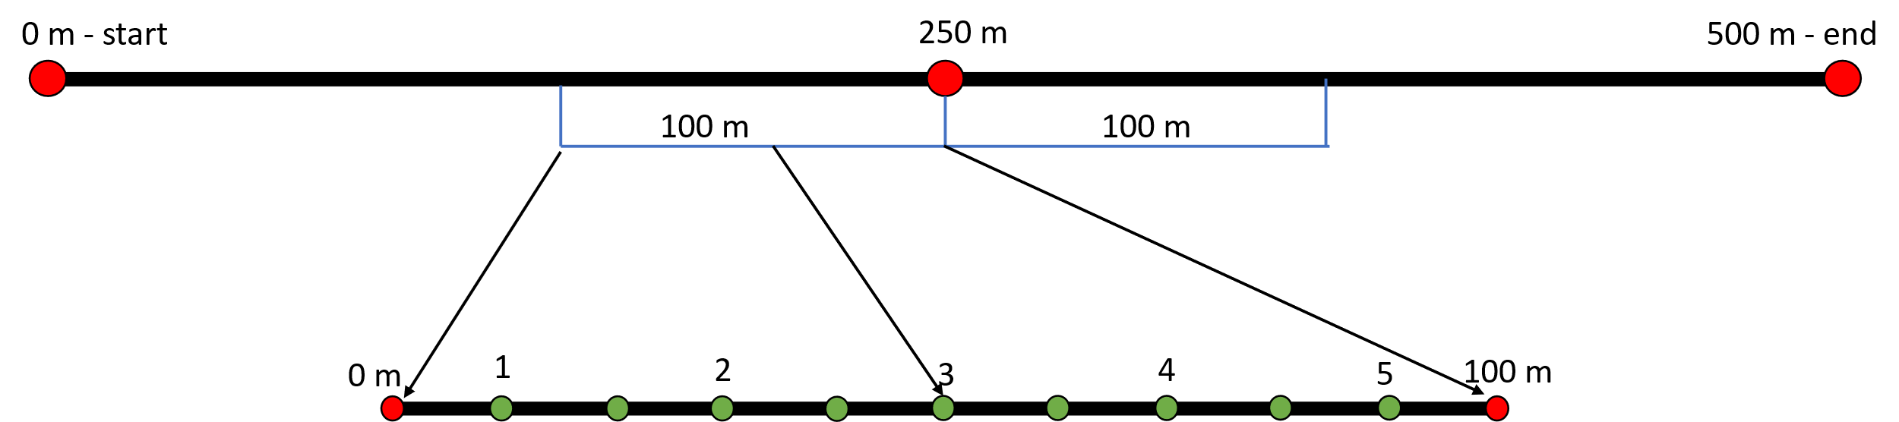

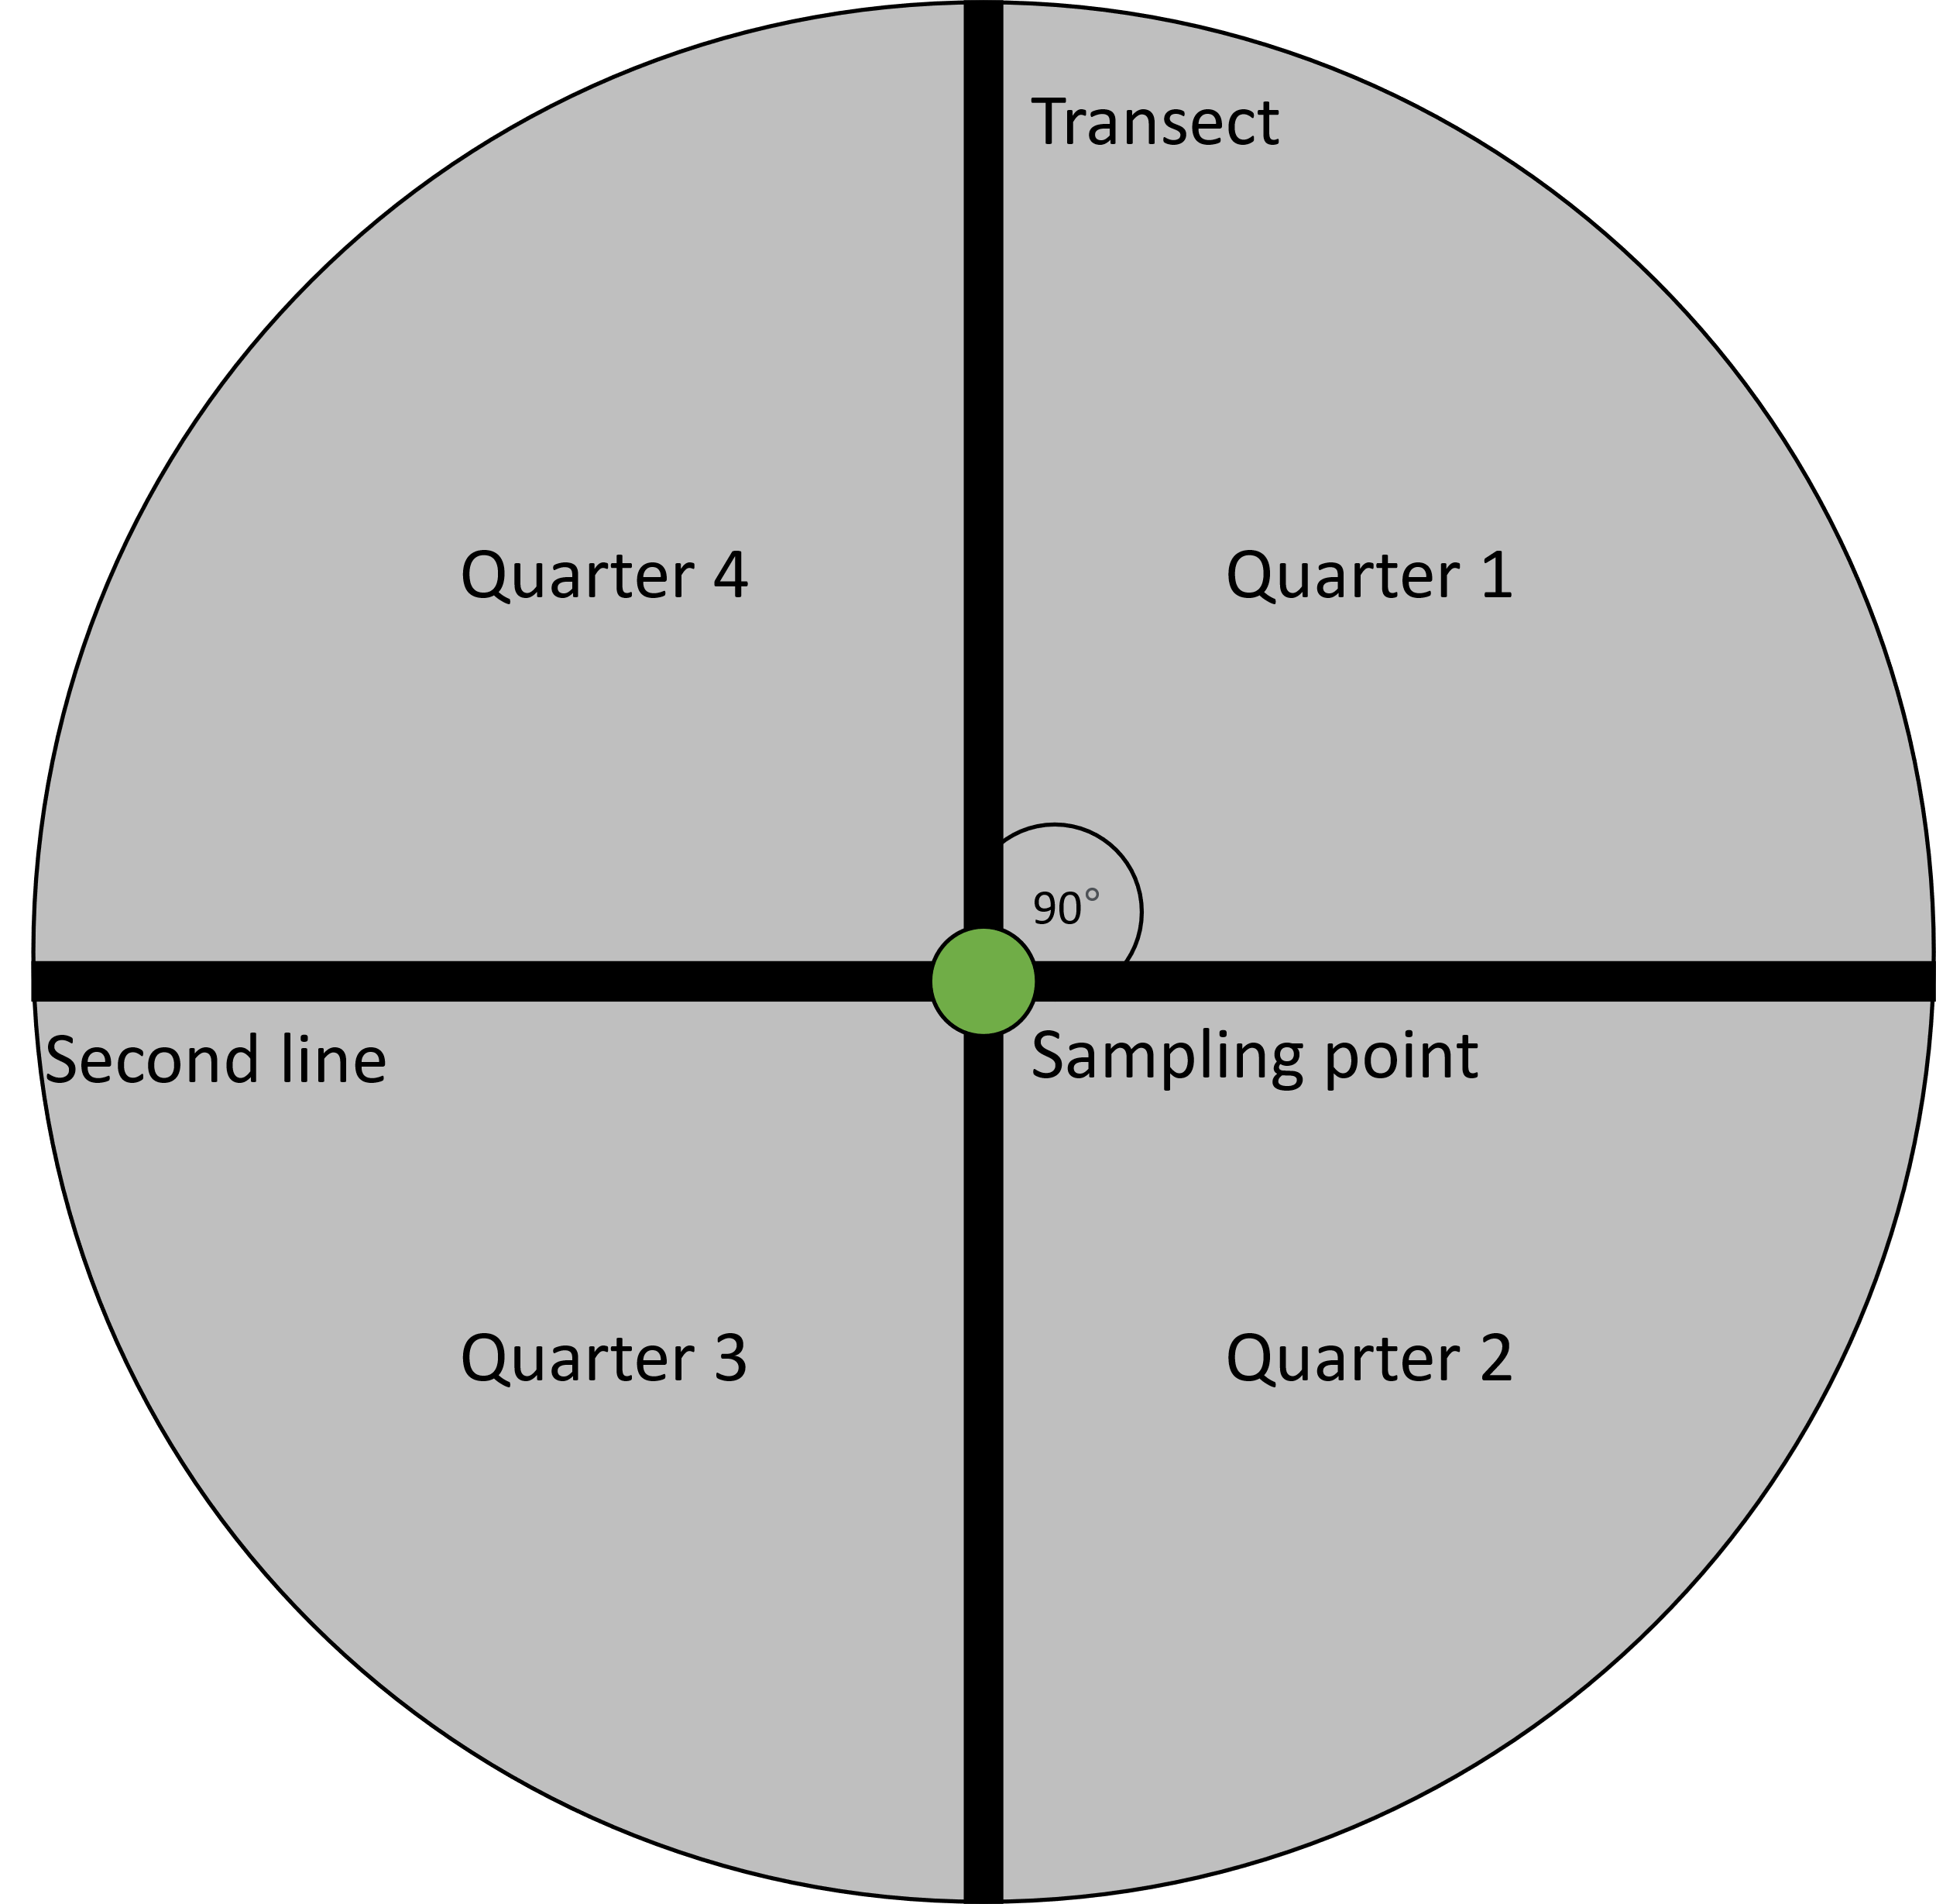

**Figure S2. *Post-fire* transect and plot design: A 200-meter section (top) of the 500-meter spotlighting transect was used to establish 10 PCQM plots (bottom). Each plot was spaced 20 meters apart. At each plot, we measured the distance, bearing, dbh and hollow-occurrence of the closest alive tree per quarter. The figure illustrates a 100-meters subsection of the 200-meter PCQM transect to illustrate plot placement (plots 1-5 of 10). In this case, the 200-meter PCQM transect starts at the 150 meter mark of the 500-meter spotlighting transect and ends at the 350-meter mark.**

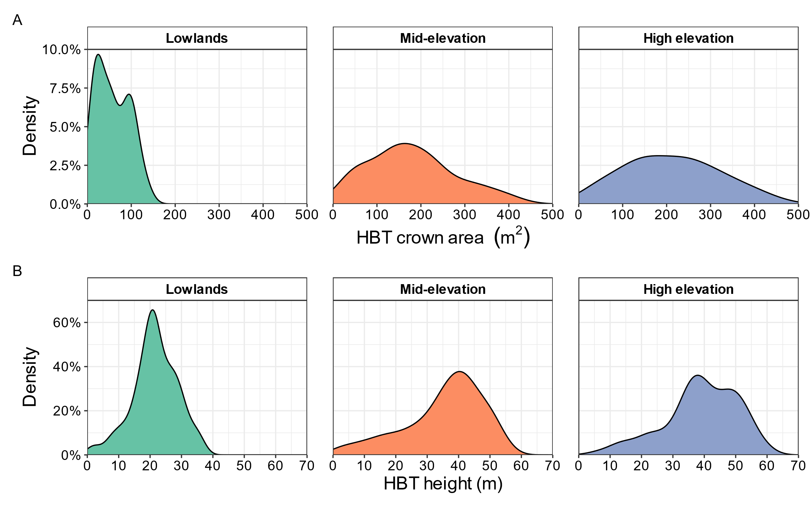

**Figure S3. *Pre-fire* HBT crown area (A) and tree height (B) distribution by elevation band.**

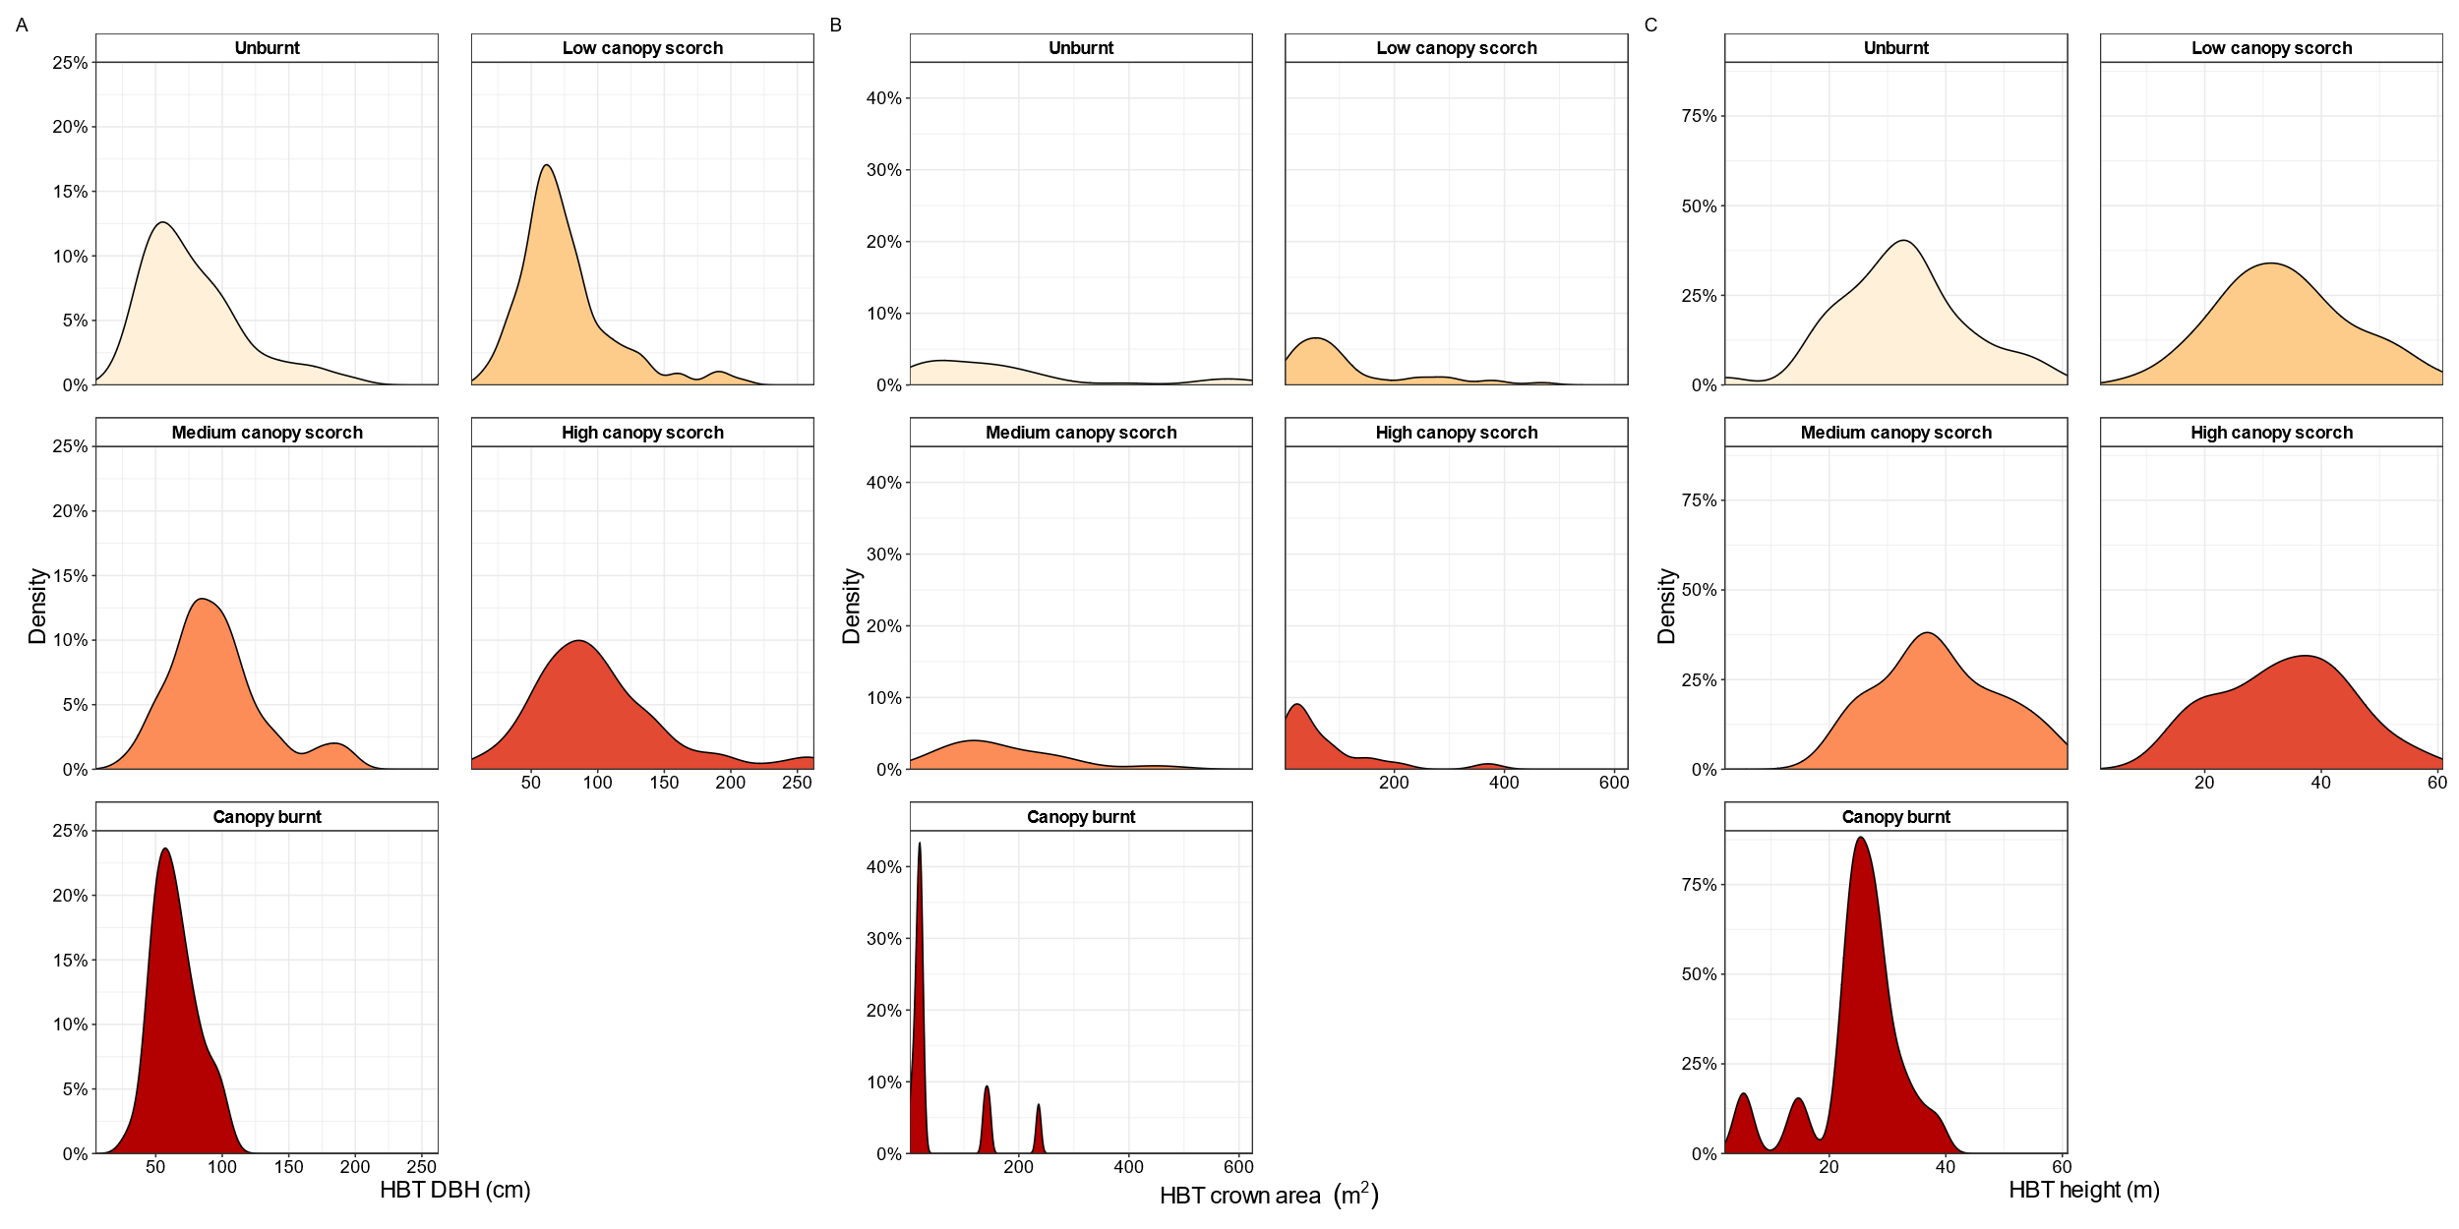

**Figure S4. *Post-fire* HBT diameter (A), crown area (B) and height (C) distribution by fire severity.**

**Figure S5. Fire severity mapping of the 2019/20 Black Summer bushfires for East Gippsland, Victoria, between Orbost (lowlands) and Goongerah (mid- to high-elevation), illustrating the homogeneity and patchiness of the fires, resulting in a mosaic of impacts on habitat suitability for arboreal fauna.**

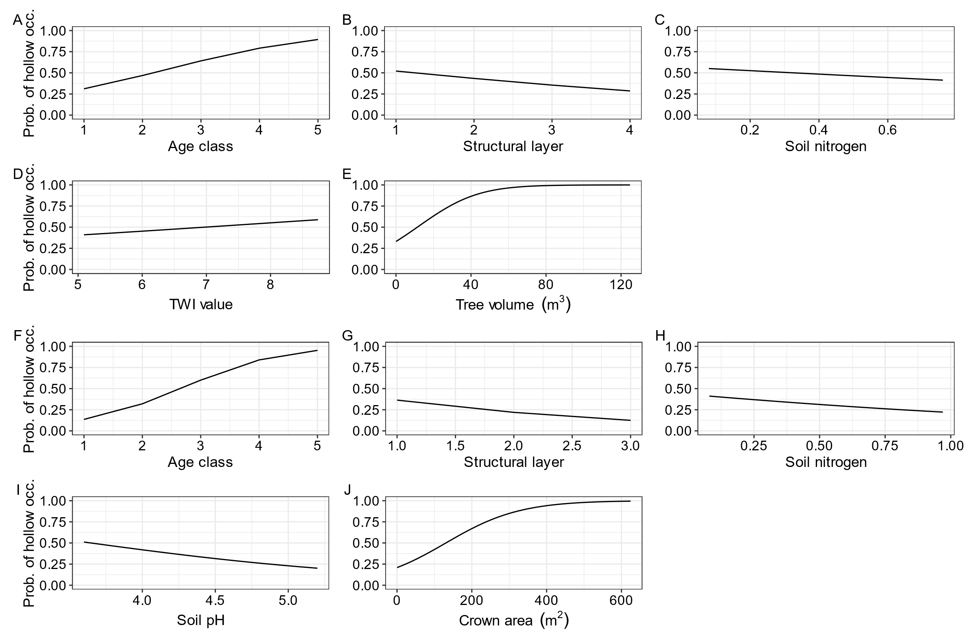

Figure S6. Partial variable dependencies of the final (combined) hollow occurrence models from pre-fire (A-E) and post-fire (F-J) data illustrating the effects and relationship direction for important variables.

# Appendix S2: Supplementary Tables

**Table S1. Variable collected in pre- and post-fire plots the plot for trees within basal area factor (BAF) = 4.**

|  |  |
| --- | --- |
| Variable | Details |
| Species | Scientific name of tree species encountered in the plot |
| Diameter at breast height (DBH) | Tree diameter in cm measured at 1.3 m above the ground |
| Height | Tree height in meters, determined using a Vertex clinometer |
| Crown width | Length of crown in meters as projected on the ground from North to South and East to West. Used to determine crown area |
| Tree vigour | Tree vigour in three health categories (alive, senescing and dead) |
| Age class | Estimate of tree age based on structure in five categories (regrowth, mature, over-mature, late-mature, stag) |
| Structural layer | Description of structural layer a tree belonged to based on dominance and height in four categories (understorey, midstorey, subcanopy, canopy) |
| Presence and number of hollows | Trees were scanned for hollows using binoculars. When hollows were present, their numbers were counted |
| Type of hollows and size | Hollow type in different categories (e.g. fissure, trunk, chimney or slit), size classes: <5 cm, 5-20cm, >20cm |
| Foliage cover | Estimated percentage of foliage cover projected on ground level |

**Table S2. Arboreal hollow-dependent species observations from *post-fire spotlighting surveys* with at least one species observation by observer, sorted by site elevation from lowest to highest. Site names match uploads to the Victorian Biodiversity Atlas (**[**vba.dse.vic.gov.au/vba**](https://unimelbcloud-my.sharepoint.com/personal/craign_unimelb_edu_au/Documents/craign/Students/Ben%20Wagner/2021/vba.dse.vic.gov.au/vba)**). If a site name is not present in the table, no arboreal species were observed during spotlighting surveys.**

|  |  |  |  |  |  |
| --- | --- | --- | --- | --- | --- |
| **Elevation band** | **Site name** | **2019/20 Fire severity** | **Observer** | **Species** | **No. of observations** |
| Lowlands | T15P5 | Unburnt | 1 | Common Brush-tailed Possum | 2 |
| 1 | Southern Boobook | 1 |
| 1 | Southern Greater Glider | 2 |
| 1 | Sugar Glider | 1 |
| 2 | Sugar Glider | 1 |
| 1 | Yellow-bellied Glider | 1 |
| 2 | Yellow-bellied Glider | 1 |
| T1P1 | Low canopy scorch | 1 | Southern Boobook | 1 |
| 2 | Southern Boobook | 2 |
| T15P2 | Canopy burnt | 1 | Sugar Glider | 1 |
| 2 | Southern Boobook | 1 |
| T1P2 | 1 | Sugar Glider | 1 |
| T15P4 | 1 | Yellow-bellied Glider | 1 |
| 2 | Yellow-bellied Glider | 1 |
| T15P3 | High canopy scorch | 1 | Southern Boobook | 1 |
| 1 | Sugar Glider | 1 |
| T2P5 | 1 | Mountain Brush-tailed Possum | 1 |
| 1 | Southern Boobook | 1 |
| Mid-elevation | T1P3 | Canopy burnt | 1 | Eastern Ring-tailed Possum | 1 |
| 1 | Sugar Glider | 1 |
| T2P1 | Low canopy scorch | 1 | Eastern Ring-tailed Possum | 1 |
| 1 | Mountain Brush-tailed Possum | 1 |
| 2 | Yellow-bellied Glider | 1 |
| T25P5 | High canopy scorch | 1 | Southern Boobook | 1 |
| 1 | Sugar Glider | 3 |
| T25P3 | 1 | Mountain Brush-tailed Possum | 3 |
| 1 | Sugar Glider | 1 |
| 2 | Mountain Brush-tailed Possum | 1 |
| T25P1 | 1 | Southern Boobook | 1 |
| 1 | Sugar Glider | 1 |
| T25P2 | 1 | Mountain Brush-tailed Possum | 4 |
| 1 | Yellow-bellied Glider | 1 |
| 2 | Mountain Brush-tailed Possum | 3 |
| 2 | Sugar Glider | 1 |
| 2 | Yellow-bellied Glider | 2 |
| T2P2 | 1 | Southern Boobook | 1 |
| 2 | Mountain Brush-tailed Possum | 1 |
| 2 | Southern Boobook | 2 |
| T25P4 | 2 | Southern Greater Glider | 1 |
| 2 | Sugar Glider | 1 |
| ARI BBRR 12 | Low canopy scorch | 1 | Sugar Glider | 1 |
| T2P4 | High canopy scorch | 1 | Eastern Ring-tailed Possum | 3 |
| 1 | Mountain Brush-tailed Possum | 1 |
| 1 | Southern Boobook | 1 |
| T2P3 | 1 | Mountain Brush-tailed Possum | 1 |
| 2 | Mountain Brush-tailed Possum | 1 |
| 2 | Southern Greater Glider | 1 |
| G3F4 | 1 | Southern Greater Glider | 2 |
| 1 | Sugar Glider | 1 |
| 1 | Yellow-bellied Glider | 3 |
| 2 | Eastern Ring-tailed Possum | 1 |
| 2 | Southern Greater Glider | 2 |
| 2 | Yellow-bellied Glider | 1 |
| High elevation | ARI BBRR 43 | 1 | Mountain Brush-tailed Possum | 1 |
| 2 | Southern Greater Glider | 2 |
| ARI BBRR 20 | Low canopy scorch | 1 | Southern Greater Glider | 2 |
| 1 | Sugar Glider | 1 |
| 2 | Southern Greater Glider | 3 |
| ARI BBRR 06 | 1 | Mountain Brush-tailed Possum | 2 |
| 1 | Southern Boobook | 1 |
| 1 | Southern Greater Glider | 1 |
| 1 | Sugar Glider | 1 |
| 1 | Yellow-bellied Glider | 1 |
| 2 | Southern Greater Glider | 1 |
| 2 | Yellow-bellied Glider | 1 |
| ARI BBRR 37 | Medium canopy scorch | 1 | Mountain Brush-tailed Possum | 1 |
| 1 | Sugar Glider | 1 |
| ARI BBRR 34 | Unburnt | 1 | Mountain Brush-tailed Possum | 5 |
| 1 | Southern Greater Glider | 1 |
| ARI BBRR 35 | Low canopy scorch | 1 | Mountain Brush-tailed Possum | 2 |
| 1 | Sugar Glider | 1 |
| 2 | Sugar Glider | 1 |
| ARI BBRR 14 | 1 | Southern Boobook | 1 |
| 1 | Southern Greater Glider | 5 |
| 1 | Yellow-bellied Glider | 1 |
| 2 | Southern Greater Glider | 4 |
| ARI BBRR 42 | Medium canopy scorch | 1 | Southern Greater Glider | 1 |
| 1 | Sugar Glider | 1 |
| 2 | Southern Greater Glider | 4 |
| T35P1 | Unburnt | 1 | Southern Greater Glider | 5 |
| 1 | Yellow-bellied Glider | 1 |
| 2 | Southern Greater Glider | 6 |
| ARI BBRR 45 | Medium canopy scorch | 1 | Mountain Brush-tailed Possum | 2 |
| 1 | Southern Greater Glider | 10 |
| 2 | Mountain Brush-tailed Possum | 2 |
| 2 | Southern Greater Glider | 6 |
| T3P5 | Unburnt | 1 | Eastern Ring-tailed Possum | 2 |
| 1 | Mountain Brush-tailed Possum | 2 |
| 2 | Common Brush-tailed Possum | 1 |
| 2 | Southern Boobook | 1 |
| T3P1 | 2 | Mountain Brush-tailed Possum | 1 |
| 2 | Southern Boobook | 1 |
| 2 | Sugar Glider | 1 |
| 2 | Yellow-bellied Glider | 1 |
| T35P5 | 1 | Mountain Brush-tailed Possum | 3 |
| 1 | Southern Boobook | 3 |
| 1 | Southern Greater Glider | 1 |
| 1 | Sugar Glider | 1 |
| 2 | Mountain Brush-tailed Possum | 4 |
| 2 | Southern Greater Glider | 2 |
| ARI BBRR 26 | Low canopy scorch | 1 | Southern Greater Glider | 2 |
| 1 | Sugar Glider | 1 |
| 2 | Mountain Brush-tailed Possum | 1 |
| 2 | Southern Greater Glider | 4 |
| T3P2 | Unburnt | 1 | Mountain Brush-tailed Possum | 1 |
| ARI BBRR 03 | Low canopy scorch | 1 | Eastern Ring-tailed Possum | 1 |
| 1 | Southern Greater Glider | 1 |
| 1 | Sugar Glider | 1 |
| 2 | Eastern Ring-tailed Possum | 1 |
| 2 | Mountain Brush-tailed Possum | 3 |
| T35P2 | Unburnt | 1 | Eastern Ring-tailed Possum | 1 |
| 1 | Mountain Brush-tailed Possum | 2 |
| 2 | Eastern Ring-tailed Possum | 1 |
| 2 | Mountain Brush-tailed Possum | 2 |
| 2 | Southern Greater Glider | 1 |
| ARI BBRR 08 | Low canopy scorch | 1 | Mountain Brush-tailed Possum | 1 |
| 1 | Southern Greater Glider | 1 |
| ARI BBRR 22 | Medium canopy scorch | 1 | Mountain Brush-tailed Possum | 1 |
| 1 | Southern Greater Glider | 3 |
| 1 | Sugar Glider | 1 |
| 2 | Eastern Ring-tailed Possum | 1 |
| 2 | Southern Greater Glider | 3 |
| T35P4 | Unburnt | 1 | Mountain Brush-tailed Possum | 1 |
| 1 | Southern Boobook | 1 |
| 1 | Southern Greater Glider | 3 |
| 2 | Southern Greater Glider | 6 |
| T3P4 | 1 | Mountain Brush-tailed Possum | 2 |
| 2 | Mountain Brush-tailed Possum | 1 |
| 1 | Mountain Brush-tailed Possum | 12 |

**Table S3. Arboreal hollow-dependent species observations from *pre-fire spotlighting* surveys with at least one species observation. Site names match uploads to the Victorian Biodiversity Atlas (**[**vba.dse.vic.gov.au/vba**](https://unimelbcloud-my.sharepoint.com/personal/craign_unimelb_edu_au/Documents/craign/Students/Ben%20Wagner/2021/vba.dse.vic.gov.au/vba)**).**

|  |  |  |  |
| --- | --- | --- | --- |
| **Elevation band** | **Site name** | **Species** | **No. of observations (both observers)** |
| Lowlands | T15P1 | Ringtail possum | 4 |
| T15P2 | Southern Boobook | 1 |
| Sugar glider | 1 |
| T15P3 | Ringtail possum | 1 |
| Southern Boobook | 2 |
| T15P4 | Mt brushtail possum | 1 |
| Powerful owl | 2 |
| Southern Boobook | 1 |
| Sugar glider | 4 |
| Yellow-bellied glider | 1 |
| T15P5 | Common brushtail possum | 3 |
| Greater Glider | 2 |
| Powerful owl | 2 |
| Ringtail possum | 3 |
| Southern Boobook | 1 |
| Sugar glider | 1 |
| Yellow-bellied glider | 1 |
| T1P1 | Southern Boobook | 3 |
| Sugar glider | 1 |
| T1P2 | Southern Boobook | 1 |
| Sugar glider | 4 |
| T1P3 | Common brushtail possum | 4 |
| Southern Boobook | 2 |
| Sugar glider | 1 |
| Yellow-bellied glider | 1 |
| T1P4 | Mt brushtail possum | 1 |
| Southern Boobook | 2 |
| Sugar glider | 1 |
| T1P5 | Southern Boobook | 1 |
| Mid-elevation | T25P1 | Mt brushtail possum | 1 |
| Powerful owl | 1 |
| Southern Boobook | 2 |
| Sugar glider | 1 |
| Yellow-bellied glider | 2 |
| T25P2 | Greater Glider | 1 |
| T25P3 | Ringtail possum | 1 |
| Southern Boobook | 1 |
| T25P4 | Southern Boobook | 5 |
| T2P1 | Southern Boobook | 2 |
| T2P3 | Common brushtail possum | 1 |
| Greater Glider | 1 |
| Southern Boobook | 2 |
| Sugar glider | 2 |
| T2P4 | Mt brushtail possum | 2 |
| Southern Boobook | 1 |
| T2P5 | Southern Boobook | 1 |
| High elevation | T35P1 | Greater Glider | 22 |
| Mt brushtail possum | 2 |
| Southern Boobook | 7 |
| Sugar glider | 2 |
| T35P2 | Greater Glider | 3 |
| Mt brushtail possum | 2 |
| Southern Boobook | 2 |
| Yellow-bellied glider | 1 |
| T35P3 | Mt brushtail possum | 3 |
| Ringtail possum | 2 |
| Southern Boobook | 1 |
| Yellow-bellied glider | 1 |
| T35P4 | Greater Glider | 3 |
| Mt brushtail possum | 2 |
| Ringtail possum | 1 |
| Southern Boobook | 3 |
| Sugar glider | 1 |
| T35P5 | Greater Glider | 5 |
| Mt brushtail possum | 2 |
| Southern Boobook | 3 |
| T3P1 | Greater Glider | 5 |
| Mt brushtail possum | 16 |
| Southern Boobook | 3 |
| Yellow-bellied glider | 2 |
| T3P2 | Mt brushtail possum | 3 |
| Southern Boobook | 2 |
| T3P3 | Mt brushtail possum | 19 |
| Sooty owl | 1 |
| Southern Boobook | 3 |
| Yellow-bellied glider | 3 |
| T3P4 | Masked owl | 1 |
| Mt brushtail possum | 5 |
| Powerful owl | 1 |
| Sugar glider | 2 |
| T3P5 | Greater Glider | 2 |
| Mt brushtail possum | 3 |
| Southern Boobook | 1 |
| Yellow-bellied glider | 1 |

**Table S4. Site description for all 49 (pre & post-fire) study sites. Unburnt sites T1P5, T15P1&5 were only sampled during pre-fire surveys, while ARI BBRR 34 was only sample during post-fire surveys. For these sites, modeling had indicated that they had burnt, but in the field we found no evidence of fire damage. *Site ARI BBRR 40 could not be surveyed for arboreal mammals due to access issues and adverse weather conditions. The site was not considered when testing for statistical differences between sites occupied or unoccupied by SGGs.**

|  |  |  |  |  |  |  |  |
| --- | --- | --- | --- | --- | --- | --- | --- |
| **Elevation band** | **Site name** | **2019/20 Fire severity** | **SGG present?** | **Elevation (m)** | **Slope (degrees)** | **Aspect (degrees)** | **Eucalyptus species present** |
| Lowlands | T15P5 | Unburnt | Y | 33 | 5 | 120 | *consideniana, cypellocarpa, globoidea, obliqua, polyanthemos, sieberi* |
| T15P1 | N | 47 | 4 | 132 | *cypellocarpa, globoidea, obliqua, polyanthemos, sieberi, tricarpa* |
| T1P1 | Low canopy scorch | N | 102 | 9 | 317 | *cypellocarpa, globoidea, sieberi* |
| T1P5 | Unburnt | N | 98 | 6 | 120 | *cypellocarpa, globoidea, muelleriana, obliqua, sieberi* |
| T15P2 | Canopy burnt | N | 210 | 9 | 135 | *consideniana, cypellocarpa, obliqua, sieberi, tricarpa* |
| T1P2 | N | 239 | 17 | 175 | *consideniana, cypellocarpa, sieberi* |
| T15P3 | High canopy scorch | N | 376 | 20 | 185 | *consideniana, cypellocarpa, sieberi, tricarpa* |
| T1P4 | N | 241 | 12 | 90 | *globoidea, sieberi* |
| T15P4 | Canopy burnt | N | 276 | 25 | 326 | *consideniana, globoidea, polyanthemos, sieberi* |
| T1P3 | N | 462 | 10 | 250 | *obliqua, tricarpa* |
| Mid-elevation | T2P1 | Low canopy scorch | N | 465 | 5 | 84 | *cypellocarpa, muelleriana, obliqua, sieberi* |
| T25P5 | High canopy scorch | N | 476 | 5 | 205 | *cypellocarpa, muelleriana* |
| T25P1 | N | 526 | 5 | 222 | *muelleriana, pseudoglobulus* |
| T2P5 | N | 381 | 10 | 280 | *cypellocarpa, muelleriana, obliqua* |
| T2P2 | N | 575 | 22 | 180 | *denticulata, fastigata, obliqua* |
| T2P4 | N | 711 | 15 | 200 | *cypellocarpa, obliqua* |
| ARI BBRR 12 | Low canopy scorch | N | 681 | 22 | 325 | *dives, obliqua, radiata, sieberi* |
| T25P2 | High canopy scorch | N | 550 | 10 | 320 | *denticulata, elata, obliqua, viminalis* |
| T25P3 | N | 515 | 6 | 220 | *cypellocarpa, obliqua, sieberi* |
| T25P4 | Y | 607 | 10 | 88 | *croajingolensis, fastigata, obliqua, viminalis* |
| T2P3 | Y | 744 | 15 | 180 | *denticulata, fastigata, obliqua, viminalis* |
| G3F4 | Y | 837 | 5 | 9 | *croajingolensis, denticulata, viminalis* |
| High-elevation | ARI BBRR 40 | High canopy scorch | * | 840 | 16 | 84 | *croajingolensis, denticulata, fastigata* |
| ARI BBRR 04 | Low canopy scorch | N | 849 | 24 | 320 | *cypellocarpa, dives, obliqua, radiata, sieberi* |
| ARI BBRR 43 | High canopy scorch | Y | 877 | 8 | 292 | *croajingolensis, fastigata, rubida* |
| ARI BBRR 20 | Low canopy scorch | Y | 883 | 19 | 215 | *cypellocarpa, fastigata, sieberi* |
| ARI BBRR 06 | N | 904 | 18 | 286 | *obliqua, radiata* |
| T3P5 | Unburnt | N | 1002 | 5 | 212 | *viminalis* |
| T35P3 | High canopy scorch | N | 850 | 18 | 150 | *denticulata, obliqua* |
| T35P5 | Unburnt | Y | 1034 | 2 | 3 | *croajingolensis, viminalis* |
| T3P1 | N | 1007 | 4 | 31 | *croajingolensis, viminalis* |
| G3F0 | Low canopy scorch | N | 930 | 10 | 40 | *consideniana, denticulata, fastigata* |
| T35P1 | Unburnt | Y | 993 | 3 | 105 | *croajingolensis, denticulata, obliqua* |
| ARI BBRR 37 | Medium canopy scorch | N | 940 | 5 | 270 | *consideniana, croajingolensis, denticulata, fastigata* |
| ARI BBRR 34 | Unburnt | Y | 942 | 5 | 161 | *croajingolensis, fastigata* |
| ARI BBRR 35 | Low canopy scorch | N | 948 | 13 | 310 | *croajingolensis, denticulata* |
| ARI BBRR 36 | N | 948 | 14 | 277 | *croajingolensis, fastigata* |
| ARI BBRR 14 | Y | 957 | 5 | 235 | *cypellocarpa, obliqua* |
| ARI BBRR 42 | Medium canopy scorch | Y | 986 | 5 | 350 | *croajingolensis, rubida* |
| ARI BBRR 45 | Y | 994 | 21 | 0 | *denticulata, fastigata* |
| T3P4 | Unburnt | N | 1232 | 14 | 95 | *denticulata* |
| T3P2 | N | 1163 | 5 | 330 | *croajingolensis, denticulata* |
| T35P2 | Y | 1176 | 11 | 121 | *denticulata, fastigata* |
| ARI BBRR 26 | Low canopy scorch | Y | 1097 | 12 | 230 | *croajingolensis, cypellocarpa, denticulata, fastigata, sieberi* |
| T35P4 | Unburnt | Y | 1227 | 3 | 185 | *croajingolensis, delegatensis, denticulata, obliqua* |
| ARI BBRR 03 | Low canopy scorch | Y | 1164 | 12 | 138 | *delegatensis, dives* |
| T3P3 | Unburnt | N | 1240 | 5 | 345 | *delegatensis, denticulata* |
| ARI BBRR 08 | Low canopy scorch | Y | 1190 | 14 | 164 | *dalrympleana, delegatensis, pauciflora* |
| ARI BBRR 22 | Medium canopy scorch | Y | 1207 | 3 | 25 | *croajingolensis, cypellocarpa, denticulata, fastigata* |

Table S5. Model results for separate final models of hollow occurrence.

|  | **Pre-fire model**  AIC = 413., R2 = 0.36 | | | **Post-fire model**  AIC = 391, R2 = 0.26 | | |
| --- | --- | --- | --- | --- | --- | --- |
| **Variable** | **Est.** *1* | **95% CI***1* | **p-value** | **Est.** *1* | **95% CI***1* | **p-value** |
| **(Intercept)** | -3.5 | -5.8, -1.4 | 0.001 | 2.4 | -2.9, 7.7 | 0.4 |
| **Age class** | 0.90 | 0.64, 1.2 | <0.001 | 1.5 | 0.68, 2.5 | 0.002 |
| **Structural layer** | -0.54 | -0.96, -0.13 | 0.011 | -0.96 | -1.8, -0.28 | 0.012 |
| **Soil nitrogen** | -1.3 | -2.6, 0.00 | 0.05 | -1.4 | -2.7, -0.18 | 0.027 |
| **TWI** | 0.31 | 0.03, 0.61 | 0.034 | - | - | - |
| **Tree volume** | 0.08 | 0.05, 0.11 | <0.001 | - | - | - |
| **Crown area** | - | - | - | 0.01 | 0.01, 0.02 | <0.001 |
| **Soil pH** | - | - | - | -1.2 | -2.3, -0.16 | 0.026 |
| *1* Est. = standardised estimate, CI = Confidence Interval | | | | | | |

# Appendix S3: Multivariate hollow occurrence grouped model results

***Pre-fire grouping***

In the forest structure variable group, DBH, tree height, age class, health (vigour) category and tree structural layer best explained hollow occurrence. When simplifying the model by calculating tree volume from DBH and tree height (H) (Eq. 1, assuming stems having a conical shape), model performance improved, and significant variables of the best model reduced to volume, age class, and tree structural layer. The tree’s age class (regrowth, mature, over-mature, late-mature, or dead stag) was equally important as volume for hollow occurrence (both p < 0.001).

(Equation 1)

In the site variable group, TWI and AHMI had significant effects (both p < 0.01) on hollow occurrence, in both models using all uncorrelated site variables and with climate variables only. Hollow occurrence was best explained by soil nitrogen (N) in the nutrients group, the relationship indicated a negative effect of soil nitrogen on probability of tree-level hollow occurrence.

***Post-fire grouping***

We found similar variables to be important in predicting hollow occurrence in post-fire trees with some variation. The best model in the structure variable group contained age class (p < 0.001), crown area (p < 0.001), tree volume (p < 0.0001) and structural layer (p < 0.01). In the site variable group, AHMI and TWI had the strongest effects on hollow occurrence (both p < 0.0001), but site NDVI, fire severity (both p < 0.001) and aspect (p < 0.01) also had a significant effect. In the soil chemistry group, soil nitrogen, phosphorous and soil pH were important in determining hollow occurrence (all p < 0.0001). As in pre-fire models, the effect of soil nitrogen on hollow occurrence was negative, indicating sites with lower total nitrogen had higher hollow occurrence (estimate = -1.7 ±0.46).

***Spatial variables for final models***

TWI was the strongest spatial predictor in both pre- and post-fire spatial variable groups and was therefore selected for combined models (see e.g. Table S5, Table 3). To avoid the use of values aggregated and/or averaged to the lower 250 m resolution of the MODIS-derived climate layers, we re-extracted TWI values from the initial higher resolution Landsat rasters (30 x 30 m) for use in the final, combined models.